Nash Reilly

Lameres/EE 367

January 28, 2011

Homework #2: Simulating Basic Gates in Modelsim

**Basic Gates Waveforms**

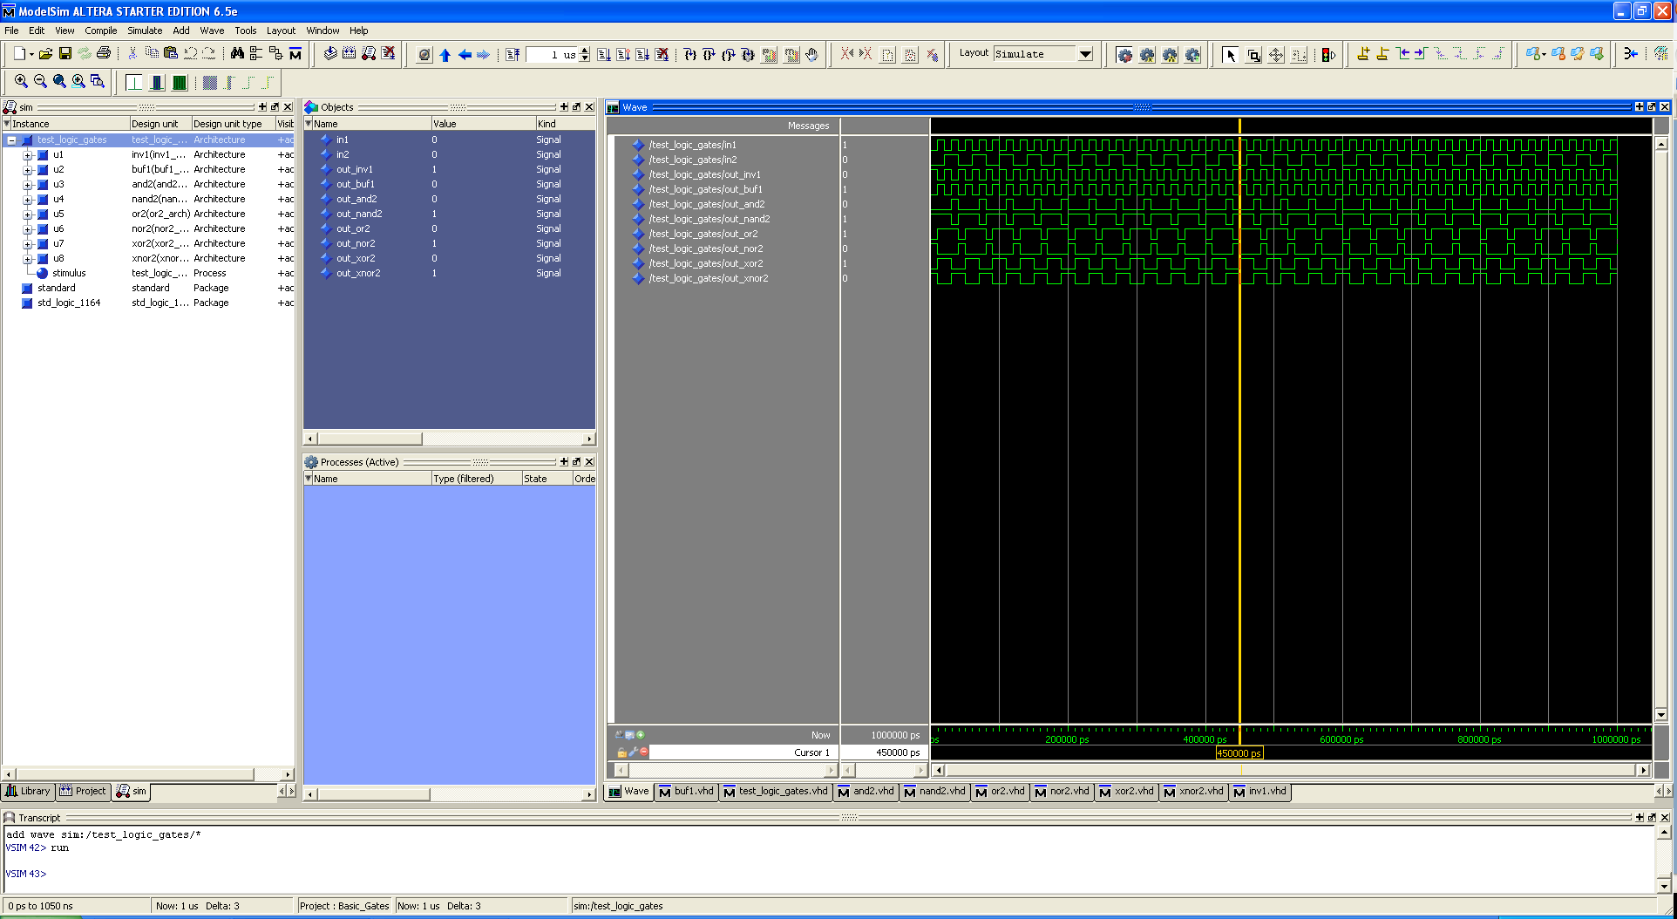

**VHDL Code**

Buf1.vhd

library IEEE; -- this library adds additional capability for VHDL use IEEE.STD_LOGIC_1164.ALL; -- this package has "STD_LOGIC" data types

entity buf1 is

port (In1 : in STD_LOGIC;

Out1 : out STD_LOGIC);

end entity buf1;

architecture buf1_arch of buf1 is

begin

Out1 <= In1;

end architecture buf1_arch;

and2.vhd

library IEEE; -- this library adds additional capability for VHDL

use IEEE.STD_LOGIC_1164.ALL; -- this package has "STD_LOGIC" data types

entity and2 is

port (In1, In2 : in STD_LOGIC;

Out1 : out STD_LOGIC);

end entity and2;

architecture and2_arch of and2 is

begin

Out1 <= In1 and In2;

end architecture and2_arch;

nand2.vhd

library IEEE; -- this library adds additional capability for VHDL

use IEEE.STD_LOGIC_1164.ALL; -- this package has "STD_LOGIC" data types

entity nand2 is

port (In1, In2 : in STD_LOGIC;

Out1 : out STD_LOGIC);

end entity nand2;

architecture nand2_arch of nand2 is

begin

Out1 <= In1 nand In2;

end architecture nand2_arch;

or2.vhd

library IEEE; -- this library adds additional capability for VHDL

use IEEE.STD_LOGIC_1164.ALL; -- this package has "STD_LOGIC" data types

entity or2 is

port (In1, In2 : in STD_LOGIC;

Out1 : out STD_LOGIC);

end entity or2;

architecture or2_arch of or2 is

begin

Out1 <= In1 or In2;

end architecture or2_arch;

nor2.vhd

library IEEE; -- this library adds additional capability for VHDL

use IEEE.STD_LOGIC_1164.ALL; -- this package has "STD_LOGIC" data types

entity nor2 is

port (In1, In2 : in STD_LOGIC;

Out1 : out STD_LOGIC);

end entity nor2;

architecture nor2_arch of nor2 is

begin

Out1 <= In1 nor In2;

end architecture nor2_arch;

xor2.vhd

library IEEE; -- this library adds additional capability for VHDL

use IEEE.STD_LOGIC_1164.ALL; -- this package has "STD_LOGIC" data types

entity xor2 is

port (In1, In2 : in STD_LOGIC;

Out1 : out STD_LOGIC);

end entity xor2;

architecture xor2_arch of xor2 is

begin

Out1 <= In1 xor In2;

end architecture xor2_arch;

xnor2.vhd

library IEEE; -- this library adds additional capability for VHDL

use IEEE.STD_LOGIC_1164.ALL; -- this package has "STD_LOGIC" data types

entity xnor2 is

port (In1, In2 : in STD_LOGIC;

Out1 : out STD_LOGIC);

end entity xnor2;

architecture xnor2_arch of xnor2 is

begin

Out1 <= In1 xnor In2;

end architecture xnor2_arch;